External Users Facing Screens External Users Facing Screens

This document contains information for internal use only.

Copyright Xoserve. All rights reserved.

Author (for this version): | Wipro Technologies
Owner: | Xoserve
Document Reference: | input.doc
Version: | 2.0
Status: | Approved
Date: | 9th February 2016

Table of Contents
1. Introduction 2
2. External Facing Screens 3
2.1. View Shipper Energy Imbalance Details 3
2.1.1. Single Shipper’s Energy Imbalance 3
2.1.2. Shipper Energy Imbalance Details 7
2.2. Nominations - System Balancing 10
2.2.1. View Business Associates Balance Details 11
2.2.2. View Business Associates Balance Details (By Hour) 14
3. Document Control 15

Introduction

This document is a collection of external screens that will be updated for the COR3572 EU Code
Changes: to be delivered in April 2016. This version has been updated.

Throughout the document GB refers to 15/15 reference temperature and EU refers to 0/25 reference temperature.

External Facing Screens

View Shipper Energy Imbalance Details

Single Shipper’s Energy Imbalance

The Energy Imbalance details in this screen will be shown in GB Units for all Locations, irrespective of whether they operate in GB units or EU units. The value of the energy difference, to convert from EU to GB Units for imbalance calculations, will be displayed in the screen with the lowest level of detail i.e. allocation by Meter ID/Location.

The values in the screen below will be shown in GB Units, irrespective of whether they operate in GB units or EU units.
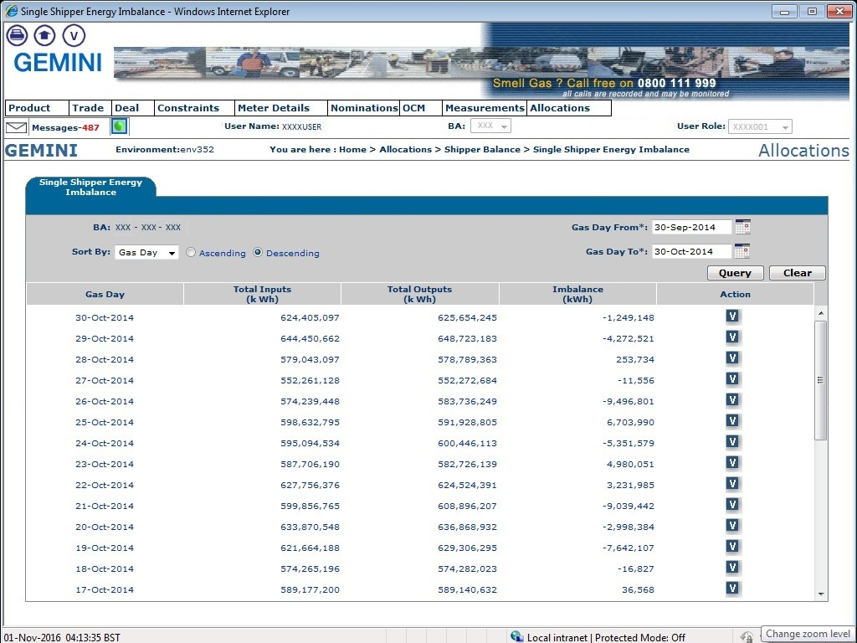

The values in the screen below will be shown in GB Units, irrespective of whether they operate in GB units or EU units.
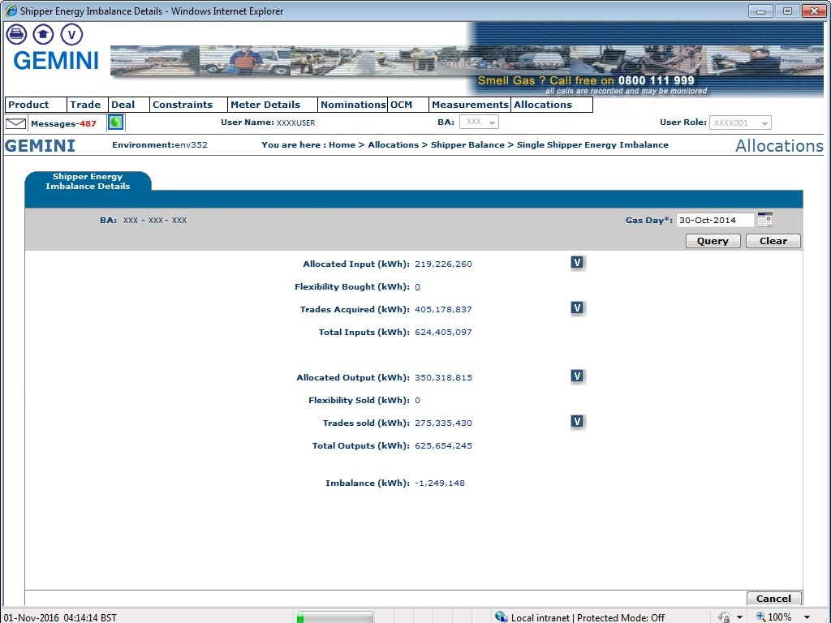

The values in the screen below will be shown in GB Units, irrespective of whether they operate in GB units or EU units.
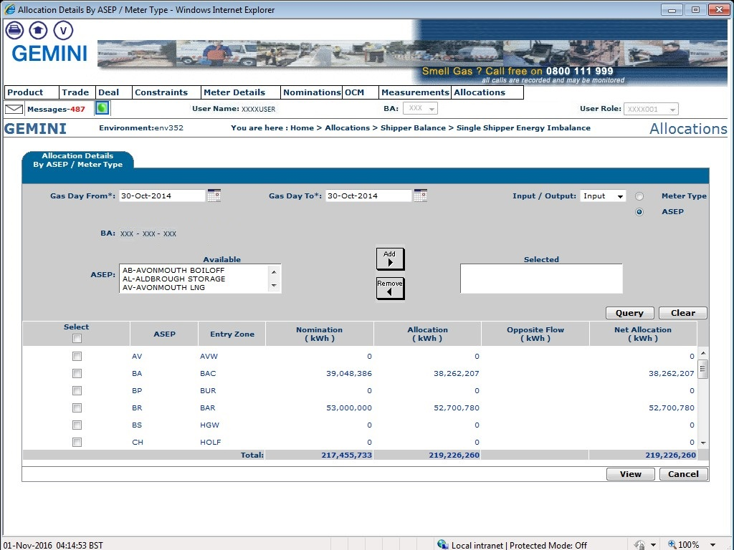

The Energy Balance details on the screen shown on the next page will be shown in EU units for all the IP Locations that will operate in EU units along with their respective Energy Difference values.
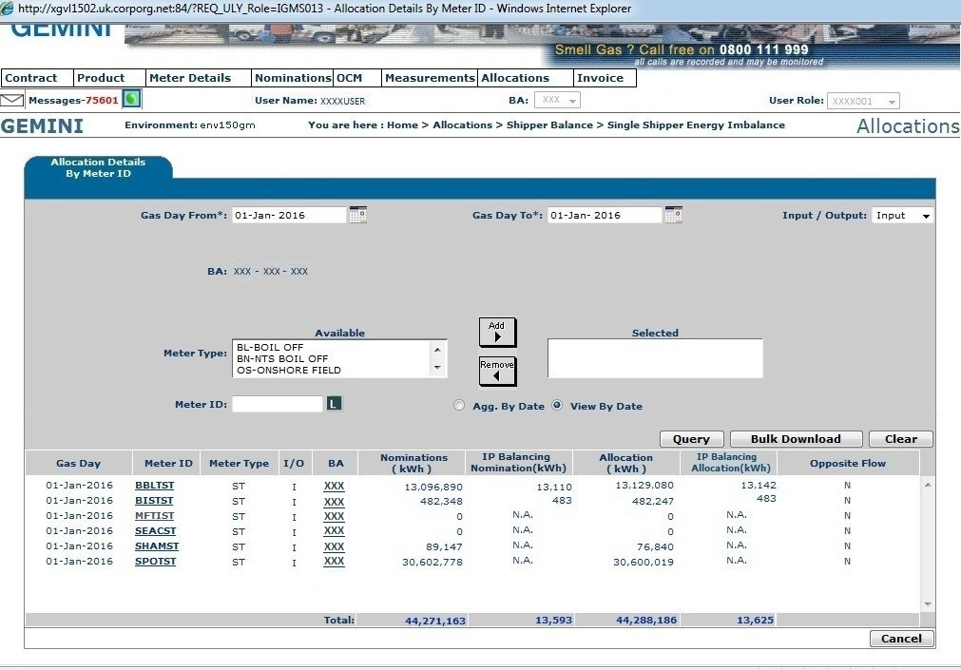
The Nomination/Allocation Values will be in EU units and the Energy Difference will be displayed in the new columns ‘IP Balancing Nomination’ and ‘IP Balancing Allocation’, for IP Locations operating in EU units.

Shipper Energy Imbalance Details

The Energy Imbalance details in this screen will be shown in GB Units for all Locations, irrespective of whether they operate in GB units or EU units. The value of the energy difference, to convert from EU to GB Units for imbalance calculations, will be displayed in the screen with the lowest level of detail i.e. allocation by Meter ID/Location.

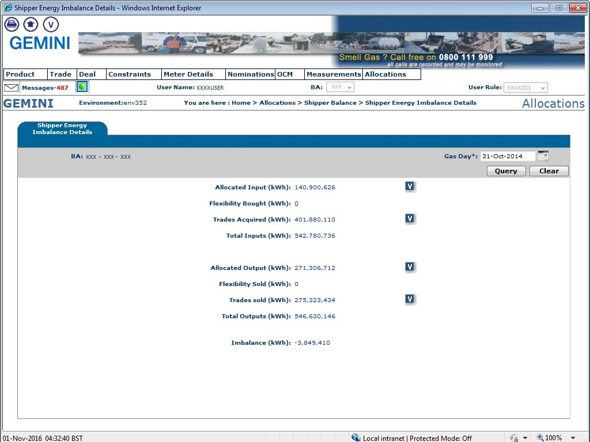
The values in the screen below will be shown in GB Units, irrespective of whether they operate in GB units or EU units.

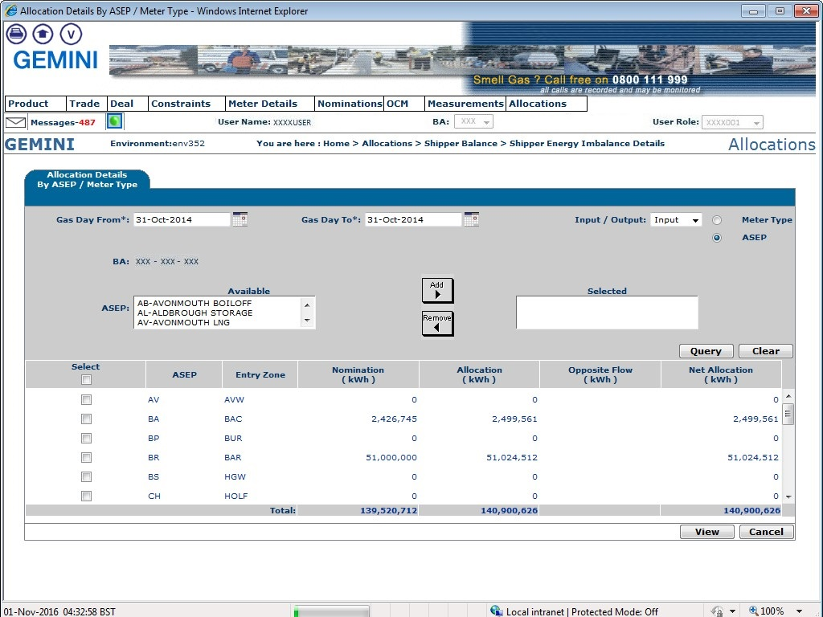
The values in the screen below will be shown in GB Units, irrespective of whether they operate in GB units or EU units.

The Energy Balance details in the screen below will be shown in EU units for all the IP Locations that will operate in EU units along with their respective Energy Difference values.
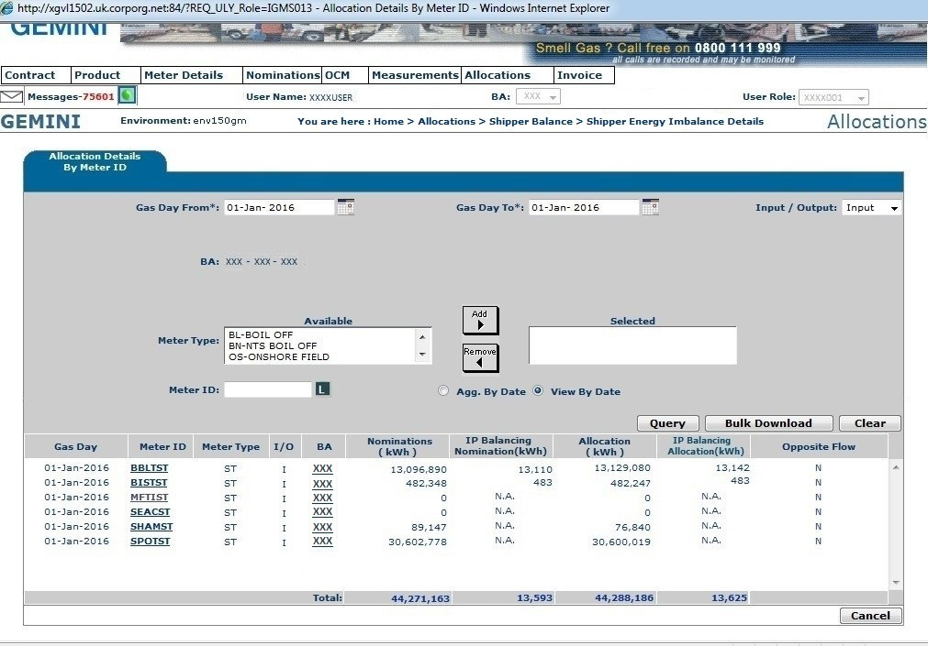
The Nomination/Allocation Values will be in EU units and the Energy Difference will be displayed in the new columns ‘IP Balancing Nomination’ and ‘IP Balancing Allocation’, for IP Locations operating in EU units.

Nominations - System Balancing

The Energy Imbalance details in this screen will be shown in GB Units, irrespective of whether they operate in GB units or EU units. The value of the energy difference, to convert from EU to GB Units for imbalance calculations, will be displayed in the screen with the lowest level of detail i.e. nominations by Meter Screen.

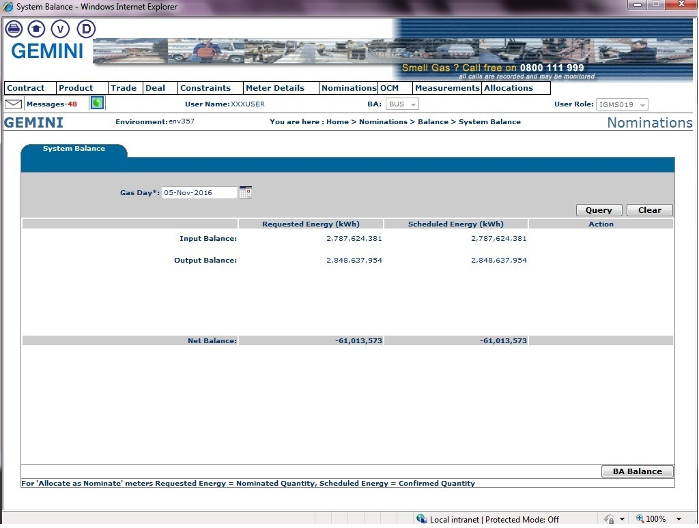
The Energy Balance details in this screen will be shown in GB units, irrespective of whether they operate in GB units or EU units.

View Business Associates Balance Details

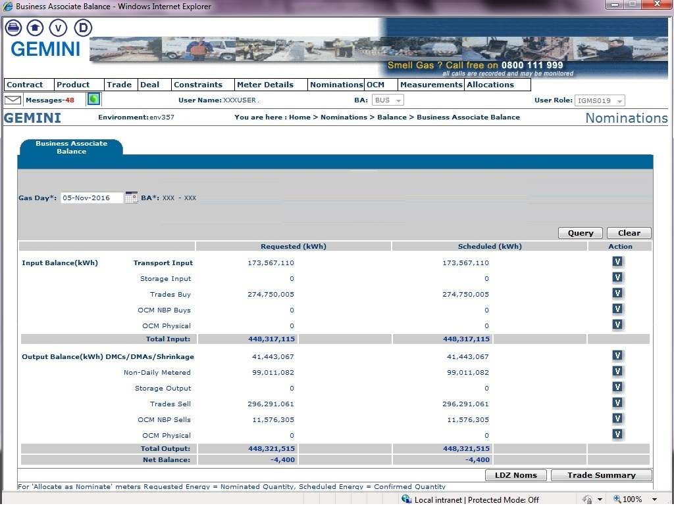
The Energy Balance details in this screen will be shown in GB units, irrespective of whether they operate in GB units or EU units.

The Energy Balance details in this screen will be shown in EU units for all the IP Locations that will operate in EU units along with their respective Energy Difference values.

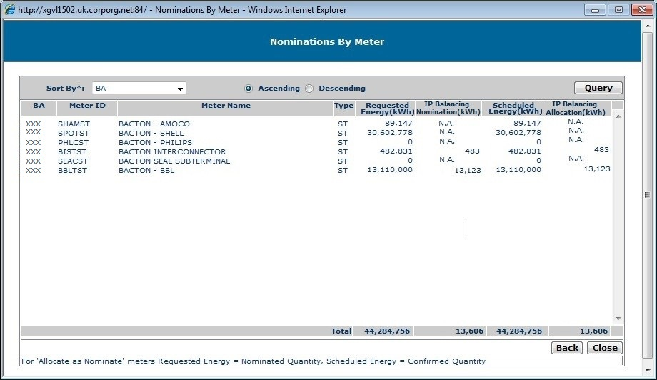
The Requested Energy and Scheduled Energy values will be in EU units and the Energy Difference will be displayed in the new columns ‘IP Balancing Nomination’ and ‘IP Balancing Allocation’, for IP Locations operating in EU units.

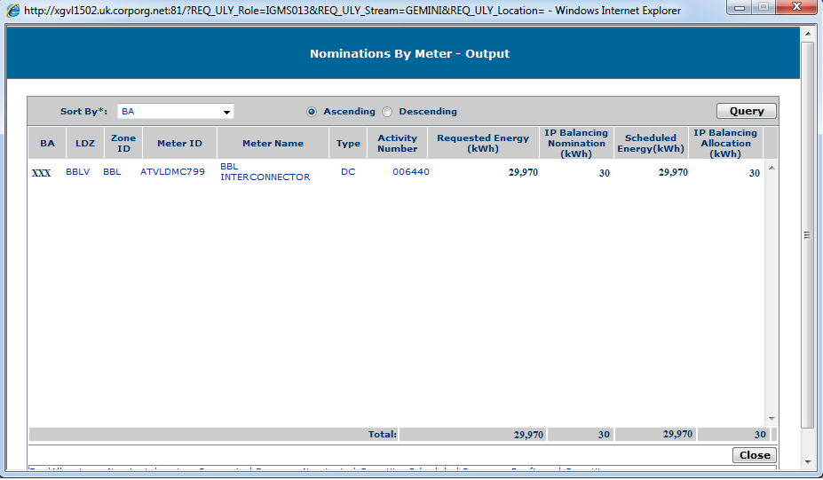

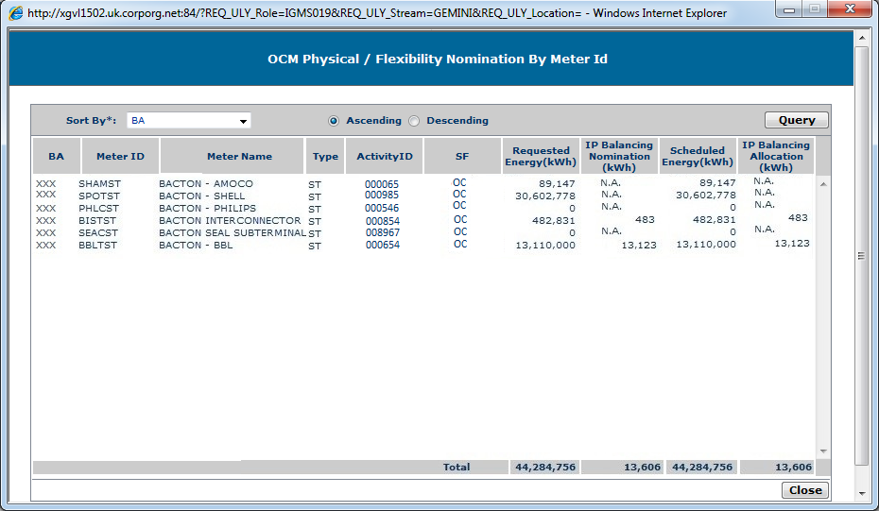

View Business Associates Balance Details (By Hour)

The Energy Balance details in this screen will be shown in GB units, irrespective of whether they operate in GB units or EU units.
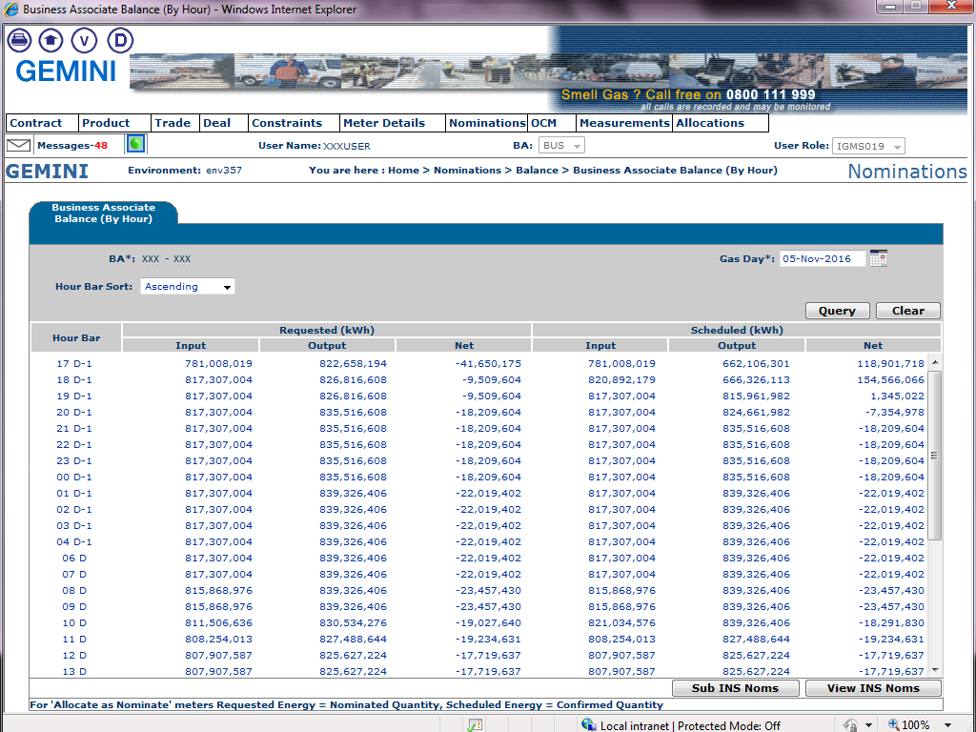

Document Control

Superseded documents
None

Version History
Version | Status | Date | Author(s) | Summary of Changes
0.1 | For Review | 06-Nov-2015 | Wipro Technologies | Initial Version
0.2 | For Approval | 04-Dec-2015 | Wipro Technologies | Issued for Approval
1.0 | Approved | 21-Dec-2015 | Wipro Technologies | Approved Version
2.0 | Approved  (Revised Version) | 09-Feb-2016 | Wipro Technologies | Approved Version with revised updates

Reviewers
Name | Role | Organisational Unit
Nicola Patmore | Project Manager | Xoserve
Rachel Addison | Project Manager | Xoserve
Bill Goode | Senior System Planning Analyst  (Project Lead) | National Grid
Greyham Davis | Analyst | National Grid
Gary Kilburn | System Planning Analyst - Gas System Operation | National Grid
Tariq Hakeem | Business Support Team Leader  (Key Business User) | National Grid
Phil Hobbins | Technical Code Development Manager | National Grid
Angela Page | Senior Business Analyst | National Grid
Dan Donovan | Service Delivery Lead  (Key Business User) | Xoserve
James Sweeney | Service Delivery Lead  (Key Business User) | Xoserve

For Information
Name | Role | Organisational Unit
Chris Wyatt | IS Delivery Lead  (Gemini System Manager) | Xoserve
Marisa LaFrenais | Gemini Team Lead | Wipro
Nathan Fellows | IS Co-ordinator | Xoserve
Matt Smith | Senior Customer & Contracts Lead  (Network Engagement) | Xoserve
Ijy George | System Consultant | TCS

Approvers
Name | Role | Organisational Unit
Jessica Harris | Senior Project Manager | Xoserve
Chris Gumbley | NG Business Change Manager  (Project Executive) | National Grid

